**UJIAN RESPONSI SEMESTER GANJIL 2020/2021**

**Nama : Tarisa Dwi Septia**

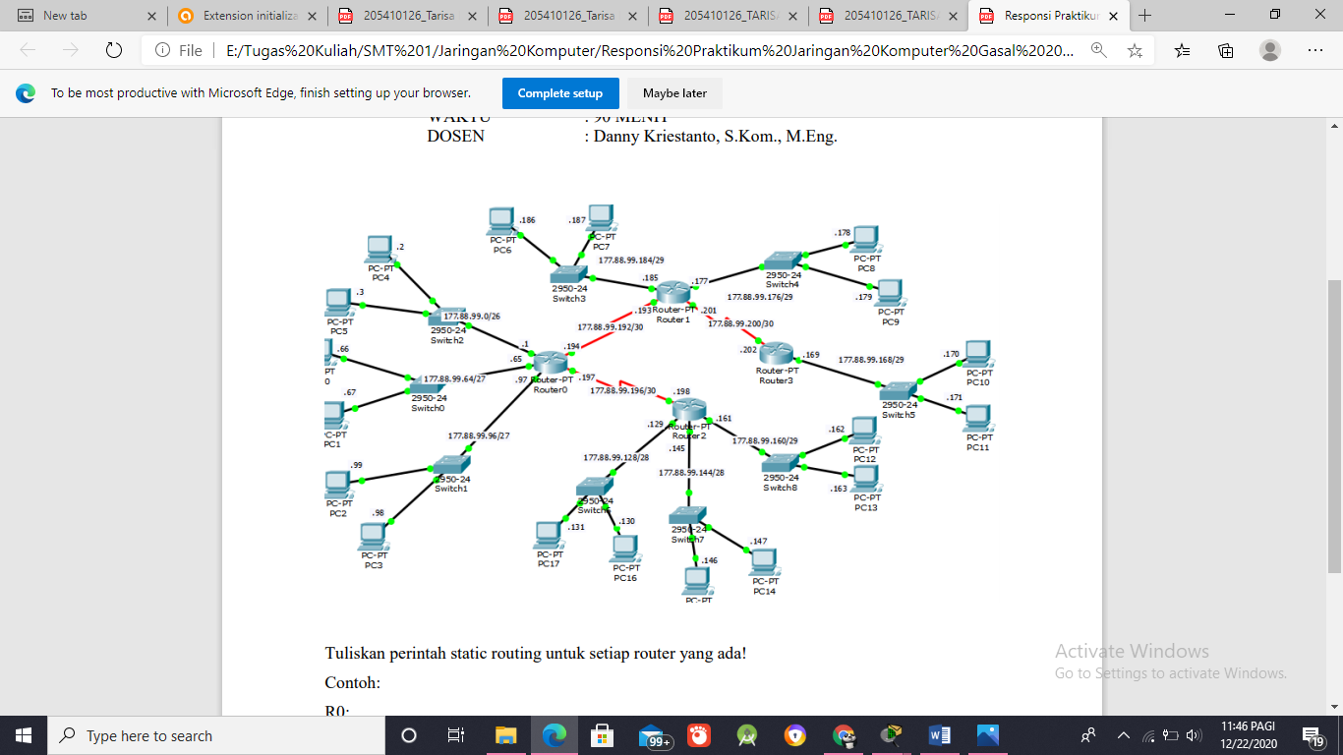**NIM : 205410126**

* 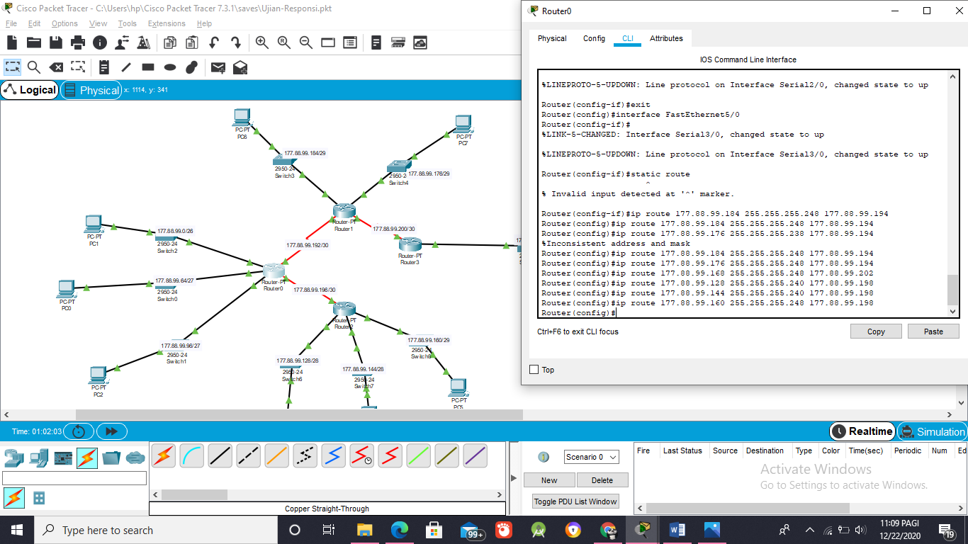R0
* 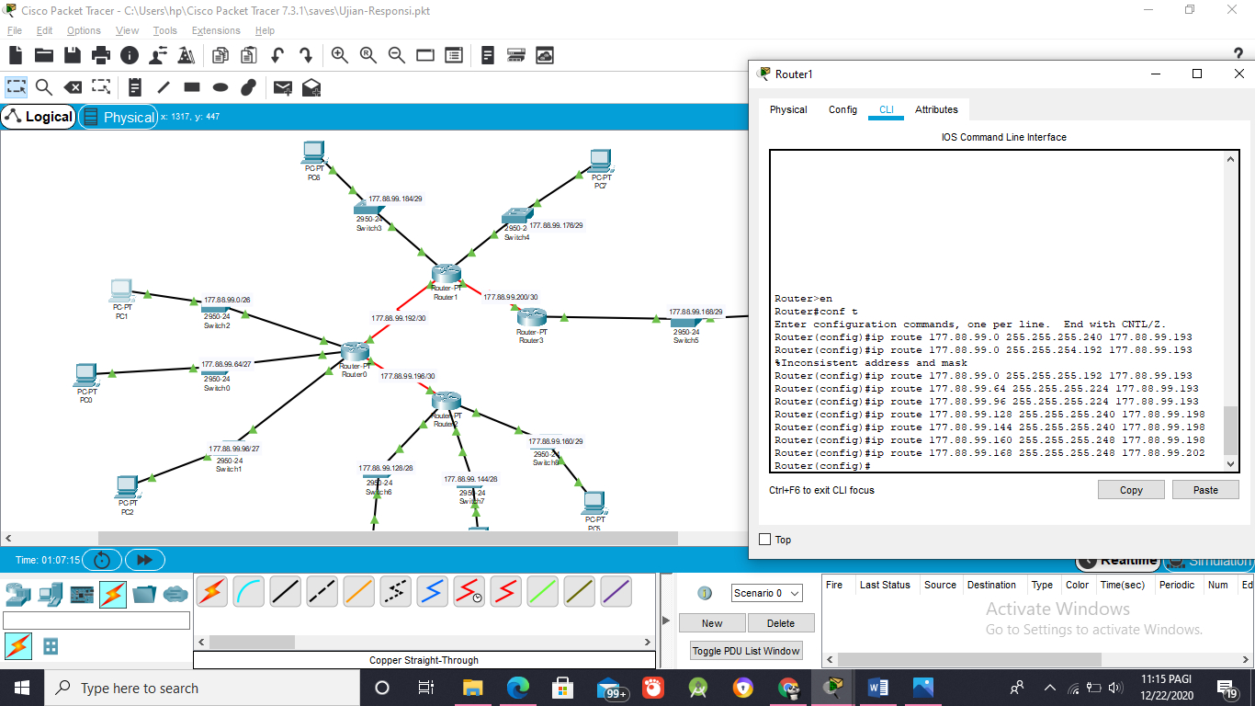R1
* 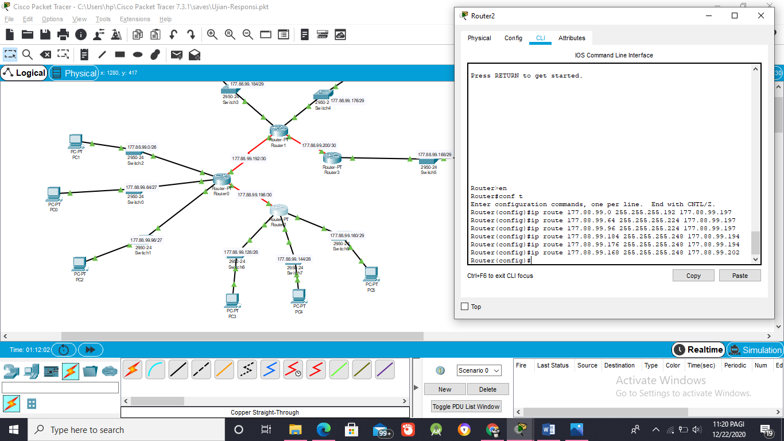R2
* 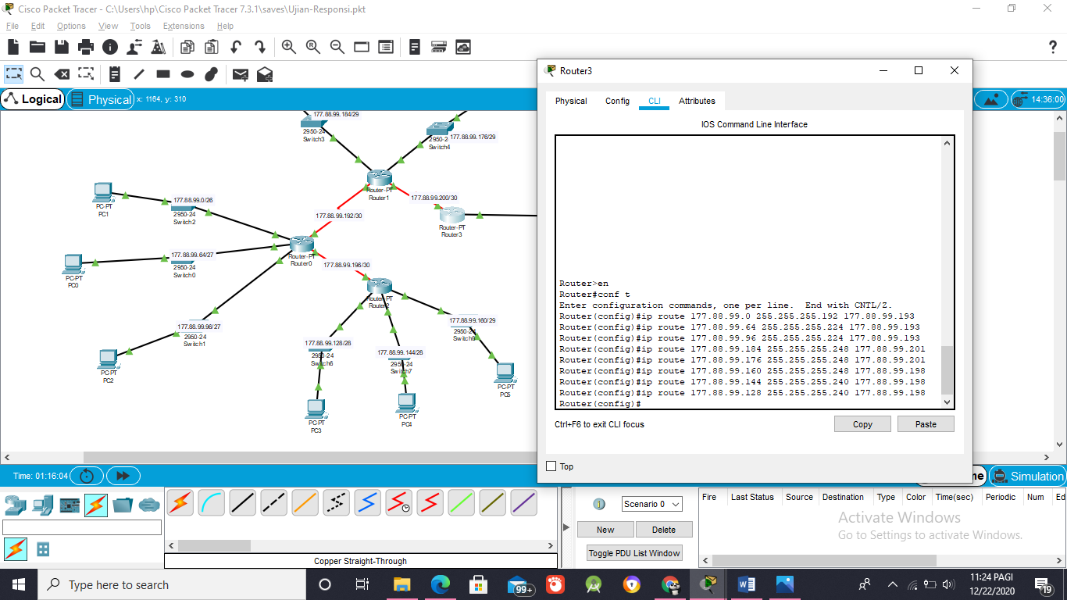R3